MEMBERSHIP NUMBER: [XYZ12345]
COMPANY NAME: [XYZ LTD]
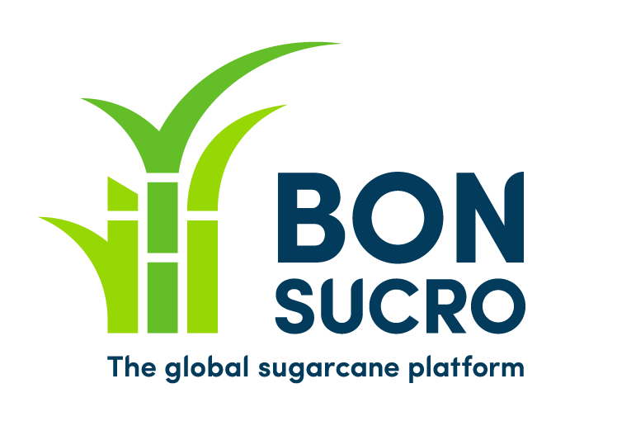
Bonsucro Logo & Certification Mark License Agreement
In consideration of the mutual covenants and promises in this Agreement, Bonsucro Limited (“Bonsucro”) and you agree as follows:
1. General. You acknowledge, for all purposes, that any and all intellectual property rights of Bonsucro, and any goodwill or other interests or rights thereto are and shall at all times remain the exclusive property of Bonsucro, and, unless expressly provided for in this Agreement, may not be used without the prior written consent of Bonsucro.
2. Grant of License. Subject to the terms and conditions of this Agreement, Bonsucro grants to you a non-exclusive, non-transferable, royalty-free license for the term of this Agreement to use its Logo & Certification Mark (the Bonsucro Certification Mark, a “Licensed Certification Mark”, depicted in Bonsucro’s Claims Labelling Rules) solely for the purposes of those activities provided for in this Agreement.
3. Use of the Logo & Licensed Certification mark. You agree to use the Logo & Licensed Certification Mark (and any associated claims wording) only in the manner outlined in Bonsucro’s Claims & Labelling Rules (as may be amended from time to time), and if for any other use, in the manner approved in advance and in writing by Bonsucro. Without prejudice to the other provisions of this Agreement (including Bonsucro’s Claims & Labelling Rules, which may be amended from time to time), you shall, when using the Logo and/or Licensed Certification Mark:
- ensure that the use is not detrimental or harmful to Bonsucro and/or the Logo and/or Licensed Certification Mark and does not damage the goodwill in the Logo and Licensed Certification mark;
- ensure that the Logo and/or Licensed Certification Mark is used in a manner which significantly distinguishes it from any surrounding adjacent text or other certification marks; and
- ensure that all advertising, promotional and other materials display a legend in a sufficiently prominent place indicating that the Licensed Certification Mark “is the property of Bonsucro and is used under license” or such other similar words to that effect as the Parties may agree.
- Ensure that any claims wording associated with the Logo and/or Licensed Certification Mark is approved in writing by Bonsucro in advance.

4. Quality Standards. You agree that when using the Logo and/or Licensed Certification Mark as contemplated by this Agreement, including, but not limited to, in all advertising and promotional materials, such use shall meet the quality and presentation standards as set forth in Bonsucro’s Claims & Labelling Rules (or any other applicable procedures manual(s)) as may be amended from time to time or as otherwise promulgated from time to time by Bonsucro; provided that with respect to amendments to such guidelines or procedure manuals, you shall be required to comply therewith as promptly as is reasonably practicable.
5. Goodwill. You acknowledge that any goodwill or other interests or rights that arise as a result of your use of the Logo and/or Licensed Certification Mark or any other intellectual property rights, as expressly permitted under this Agreement or any other agreement between the Parties, shall inure solely to the benefit of Bonsucro and you hereby assign and convey such goodwill and other interests and rights to Bonsucro without the payment of any consideration.
6. Restrictions on Use. You will not, at any time, whether during or after termination of this Agreement, use Bonsucro Logo and/or Licensed Certification Mark as part of your corporate, business or trading name or style nor will you apply for or obtain registration of the Logo and/or Licensed Certification Mark or any confusingly similar mark or logo for any goods or services in any country of the world.
7. Infringement. You will promptly notify Bonsucro in writing of any threatened, suspected or actual unauthorised use by any third party of Bonsucro’s Logo and/or Licensed Certification Mark (or any similar marks) or other intellectual property rights of which you become aware or any allegation of which you become aware that the Logo and/or Licensed Certification Mark is invalid or infringes the intellectual property rights of any third party, and you will not make any admissions in relation to the alleged invalidity, infringement or other form of attack, but shall promptly report the matter in writing to Bonsucro. Bonsucro will in its absolute discretion decide whether any proceedings will be instituted or defended in relation to the Logo and/or Licensed Certification Mark and will have the exclusive conduct of any such proceedings. You will use your reasonable endeavours to assist Bonsucro in any such proceedings. The costs and benefits of such proceedings will be borne by Bonsucro as owner of the Logo and Licensed Certification Mark.
8. Deficiencies. If you use the Logo and/or Licensed Certification Mark other than in accordance with the requirements of this Agreement, or if Bonsucro reasonably believes that your use of the Logo and/or Licensed Certification Mark, or your manner of conducting your operations in connection with the Logo and/or Licensed Certification Mark risks a disparagement or other loss to Bonsucro or the Logo and/or Licensed Certification Mark, Bonsucro shall provide notice to you of such deficient use and a method of cure, if applicable. Without prejudice to Bonsucro’s rights in respect of such deficiency under this Agreement or at law, you shall cure the deficiency in accordance with the method of cure proposed by Bonsucro or by some other reasonable means at your own as soon as reasonably practicable, but in any event within 7 days of the occurrence of such deficiency.
9. Term & Termination. This Agreement shall be effective upon the date countersigned by Bonsucro and may be terminated by you or Bonsucro at any time. This Agreement shall terminate automatically upon your loss or relinquishment of your Bonsucro certification and/or membership. Upon termination of this Agreement, you shall fully and as promptly as reasonably practicable cease all use of the Logo and/or Licensed Certification Mark, and shall, at the option of Bonsucro, as promptly as reasonably practicable, destroy all materials related to such Logo and/or Licensed Certification Mark, and certify to Bonsucro such destruction.
10. Governing Law. This Agreement shall be construed and interpreted in accordance with the laws of England & Wales.

I accept the terms and conditions of this Bonsucro Logo & Certification Mark License Agreement.
______________________________________ Signature of Legal Representative
______________________________________ Printed Name
____________________ Date

Countersigned for and on behalf of Bonsucro

__________________________________ Signature

______________________________________ Printed Name
____________________ Date

